**TEST: Math 2 Graphing Functions and Solving Equations Name: ______________**

**Match the name & equation to the graph.**

**Names**: A) linear B) quadratic C) inverse (Rational) D) square root (Radical)

**Equations**: E) y = x F) y = x2 G) H) y =

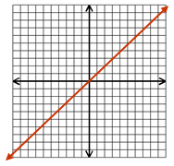1. 2.

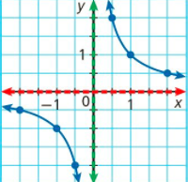

Name: Name:

Equation: Equation:

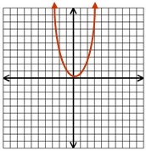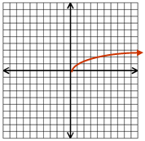3. 4.

Name: Name:

Equation: Equation:

**Identify the parent function name and equation. Then describe the transformation for each function.**

1. g(x) = 3(x-1)2 – 6 Parent Function:

Name_______________ Equation_______________

Transformations: _______________________________________

1. f(x) =  Parent Function:

Name_______________ Equation_______________

Transformations: _______________________________________

**Graph each equation. Then state the domain, range, x-intercept(s), and y-intercept.**

8.  9. 

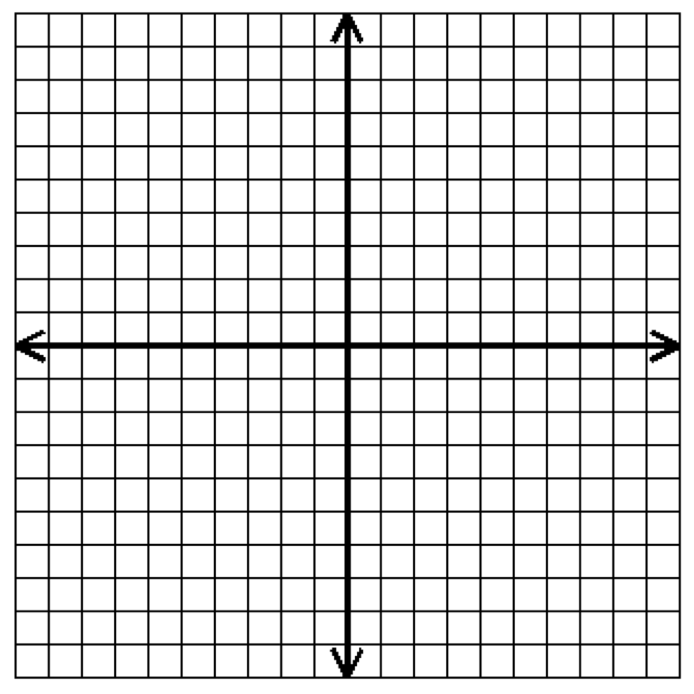 

Domain: Domain:

Range: Range:

x-intercept(s): x-intercept(s):

y-intercept(s): y-intercepts(s):

10. $y=\sqrt{x+2}-4$



Domain:

Range:

x-intercept(s):

y-intercept(s):