Math 2 Name __________________________
Review: Inverse Functions and Direct Variations Date _________________

- Solve $\frac{x}{15}= 7.2$

- Solve $\frac{10}{x}=8$

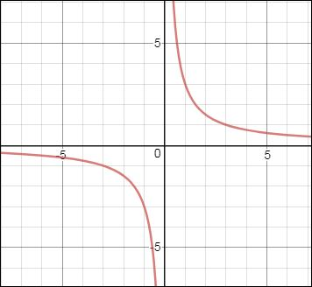
3. What is the equation of the function shown to the right? (choose the best answer)
A. $y= \frac{1}{x+1}+3$

B. $y= \frac{1}{x-1}+3$
C. $y= \frac{-3}{ x}$
D. $y= \frac{3}{x}$

4. Given: $y$ varies directly as $x$. If $y$ is 20 when $x$ is 5, find $x$ when $y$ is 28. Show all work.

5. The time ($T$) it takes to paint a building varies with the number of people ($P$) who are working.
This relationship is an inverse variation. Explain how you know this is true. __________________________________________________________________________________________________
__________________________________________________________________________________________________
__________________________________________________________________________________________________

6. Describe the transformations (from the parent function) in the equation below. (choose the best answer)
$y= \frac{1}{x-4}-5$

A. right 4 and down 5
B. left 4 and down 5
C. right 4 and up 5
D. left 4 and up 5

7. Describe the transformations shown in the equation. (choose the best answer)
$$y= \frac{-2}{ x}$$
A. reflect over $x$ - axis and right 2
B. down 2 and reflect over $x$ – axis
C. stretch 2 and reflect over $x$ – axis
D. reflect over $x$ – axis and stretch $\frac{1}{2}$

4.

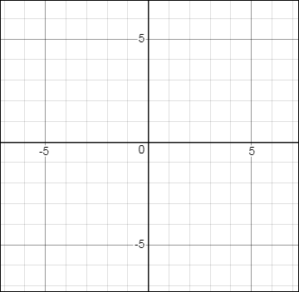
8. For the function,
$y= \frac{1}{x+2}-3$
a) List the transformations.

Draw

b) Use dashed lines to draw the asymptotes.

c) Give two guide points:
( , ) and ( , )

d) Graph the function.

9. Solve $\frac{2}{x}= 3x+5$ 10. Solve $\frac{6}{x}+\frac{2}{x}=4$

11. Solve $\left\{\begin{aligned}y=\frac{35}{x} \\ x+y=12\end{aligned}\right.$

12.
12.
a) Draw both asymptotes of the function.
b) Write the equation of the horizontal asymptote: __________________

c) Write the equation of the function:
_________________________
d) Describe the end behavior.
____________________________

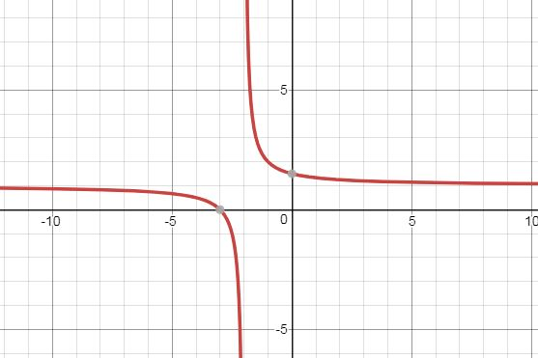

13. 13.
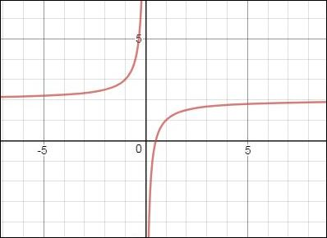
a) Write the equation of the function:

b) Give the domain: _______________________

c) Give the range: ______________________
d) The slope of this function is _____________.

14. Write the equation of a radical function that is translated 2 units down and 6 units left: $y=$____________________

16. A crew of 13 workers can paint a building in 12 hours. How long would it take a crew of 10 workers to paint the building? ________hrs (_____hr ___ min)
Show all work.

15. The time it takes to fly from Boston to Tokyo, Japan,
varies inversely as the speed of the plane. If the trip
takes 13 hours when the plane is traveling at 900 mph,
how long would it take at 1000 mph? _______
What is the constant of variation? _____
Show all work.

