1. A video club costs $25 to join. Each video that is rented costs $2.50. Let v represent the number of videos. Identify the independent and dependent variables. Then, write a rule in function notation for the situation.
A. Independent: videos rented; Dependent: total cost; $f\left(v\right)=25v+2.5$
B. Independent: videos rented; Dependent: total cost; $f\left(v\right)=2.5v+25$
C. Independent: total cost; Dependent: videos rented; $f\left(v\right)=25v-2.5$
D. Independent: videos rented; Dependent: total cost; $f\left(v\right)=2.5v-25$

2. Solve the inequality$-2c-5≥-7$ and graph the solutions.
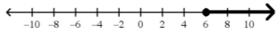
A. $c≥1$ C. $c≥6$

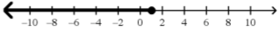
B. $c≤6$ D. $c≤1$

3. Solve $-\frac{x}{8}-\frac{5}{4}=-\frac{3x}{8}$
A. $x=-\frac{5}{8}$
B. $x=\frac{5}{8}$
C. $x=5$
D. $no solution$

4. Four times the smallest of three consecutive odd integers is five more than three times the largest. What is the sum of these three consecutive odd integers?
A. $57$
B. $51$
C. $45$
D. $39$

5. Simplify $5x-3\left(2x-4y\right)-5\left(3x+4y\right)$
A. $-16x-32y$
B. $-16x-8y$
C. $-14x-16y$
D. $-14x-32y$

6. Simplify $-4xy^{3}\left(-3xy-\frac{5x}{y}\right)$
A. $-12xy^{3}-20x^{2}y^{2}$
B. $12xy^{3}+20x^{2}y^{-3}$
C. $12x^{2}y^{4}-20x^{2}y^{2}$
D. $12x^{2}y^{4}+20x^{2}y^{2}$

7. Gino knows that the formula for converting degrees Celsius ($℃$) to Fahrenheit ($℉$) is $F=\frac{9}{5}C+32$. Which of the following is correctly solved for C?
A. $C=\frac{5F-160}{9}$
B. $C=5F-\frac{160}{9}$
C. $C=\frac{5F+160}{9}$
D. $C=\frac{5}{9}F+160$

8. On certain multiple choice tests, students earn points for correct answers, but lose points for wrong answers.

The formula to calculate a student’s score on a test is

$$S=2C-\frac{W}{4}$$

S is the student’s score, C is the number of correct answers, and W is the number of wrong answers.

Using the formula, $S=2C-\frac{W}{4}$, answer the following questions.
- Saul took the test and got 36 items correct and 12 wrong. What was his score?

- Franchesca took the test and got a score of 53. She got 29 items correct. How many did she get wrong?

- David took the test and got a score of 80. He got 8 answers wrong. How many answers did he get correct?

9. You are playing a carnival game. You now have 50 prize tokens. Each time you win a game, you will get 8 prize tokens. As soon as you get at least 100 prize tokens, you will stop playing.

The function $T\left(w\right)=50+8w$ represents the total number of prize tokens that you have after winning $w$ games.

- Fill in the missing values in the chart below.
$$w$$ | $$T\left(w\right)$$
$$0$$
$$2$$
 | $$82$$

- What are the independent and dependent variables?

Independet Variable:

Dependent Variable:
- Are the variables discrete or continuous?

- What does the statement $T\left(3\right)=74$ mean in the context of this situation?

- Complete the domain: $\{0, 1, 2,$ $\}$

- What number would replace the variable $w$ in the statement$T\left(w\right)=90$?3

10. Look at the graph below.
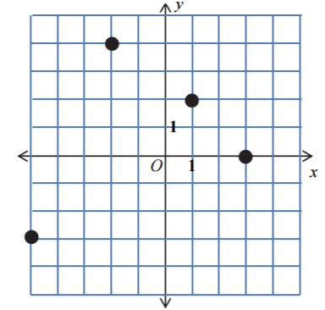

Which of the following points, if added to the graph above, will cause the relation NOT to be a function?
A. $\left(2, 3\right)$
B. $\left(4, 2\right)$
C. $\left(3, -2\right)$
D. $\left(0, -4\right)$

11. Sketch a graph on the axes below for a function $y=f\left(x\right)$ with the following characteristics.
- The function has x-intercepts of $-3$ and $2$.
- The y-intercept is 3.
- $f\left(-4\right)=-5$, $f\left(4\right)=-3$
- The function is increasing when $-4≤x≤-1$ and decreasing when $-1≤x≤4$.
- The domain of the function is $-4≤x≤4$.
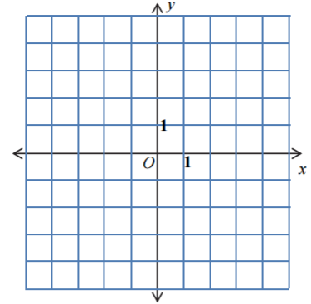
- The function is continuous.

12. In Art class students create a project with blocks in a pattern. Students will use algebra to describe the pattern. A student writes two formulas on the board.

Recursive: $a_{1}=3$, $a_{n}=2a_{n-1}$ Explicit: $a_{n}=3∙2^{n-1}$

- Write the first 5 terms of the sequence.

- You want to know the value of$a_{30}$. Is it more efficient to use the recursive or explict formula? Why?

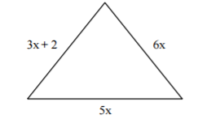
13. Determine the perimeter of the figure below.

14. The original cylinder is shown below. A new cylinder is created by doubling the radius and halfing the height of the original cylinder. Which cylinder will have a larger volume? Find the volume of each to justify your answer.
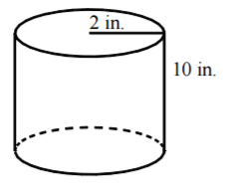

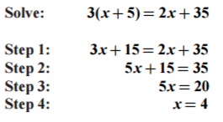
15.

Which is the first incorrect step in the solution shown above?
A. step 1
B. step 2
C. step 3
D. step 4

